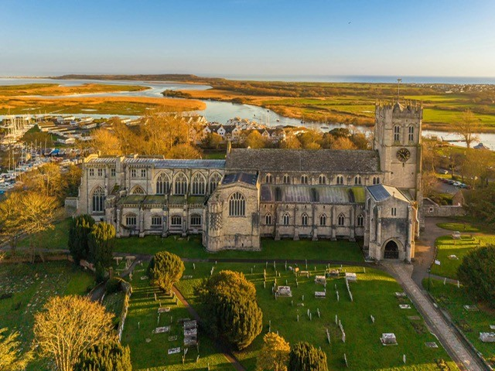

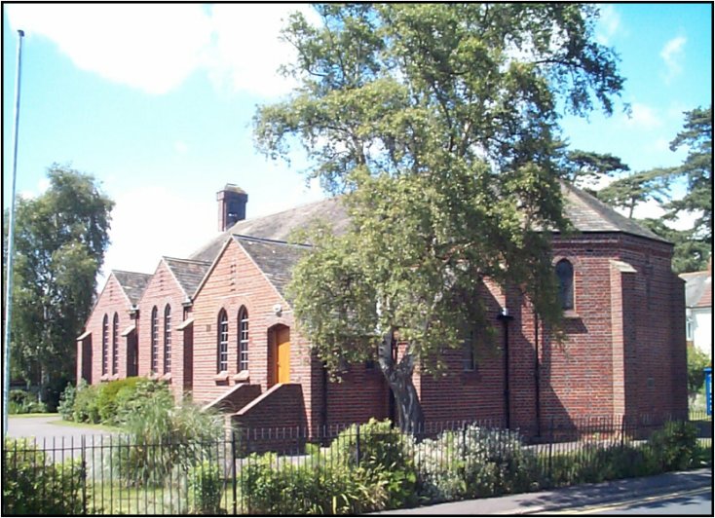

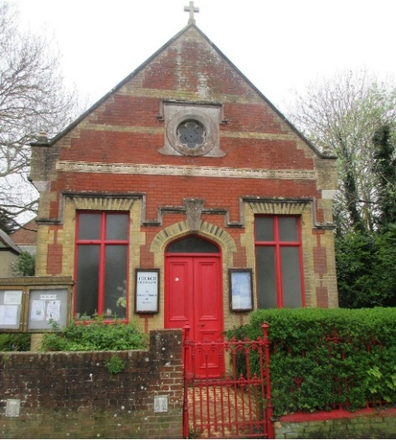

Contents Parish Map
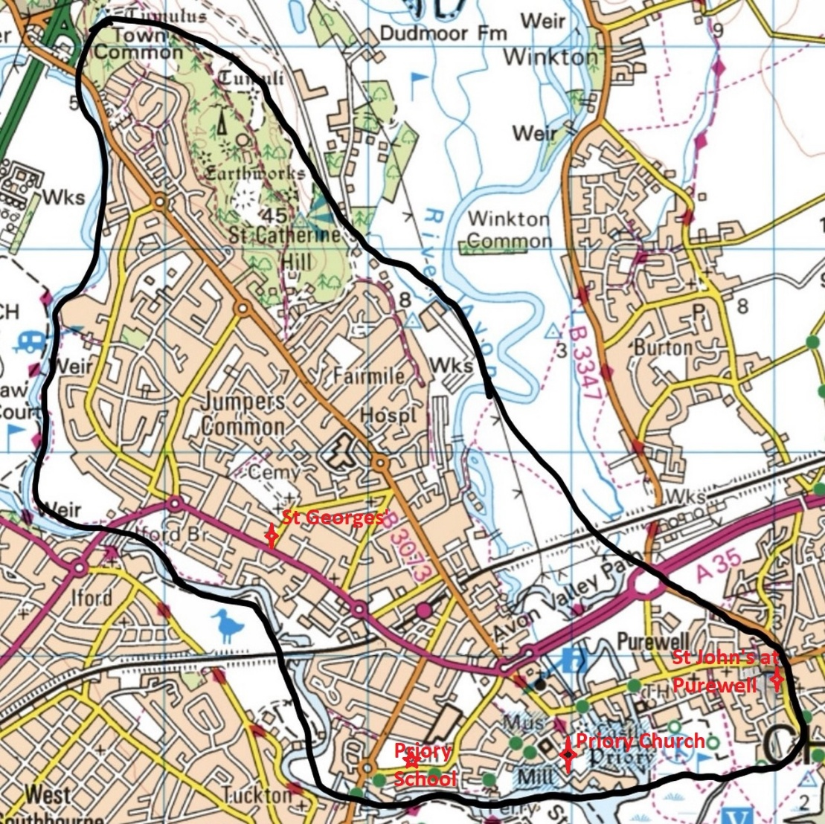
Pg 3 Welcome to Winchester Diocese
Pg 4 Welcome to Christchurch Deanery
Pg 5 Welcome to the Parish of Christchurch Profile
Pg 6 Parish Mission and Vision
Pg 7 Is this Parish for you?
Pg 8 The church buildings in the Parish
Pg 9 The schools in the Parish
Pg 10 Children and families
Pg 11 Volunteers
Pg 12 Our Organisation
Pg 13 Safeguarding
Pg 14-16 Our current team
Pg 17 Foundations for the future
Pg 18-20 Finance
Pg 21-23 Our church life
Pg 24-25 Our worshipping community
Pg 26 Music at the Priory
Pg 27-28 Other activities in the Parish
Pg 29 Commercial Enterprise
Pg 30-31 The House
Pg 32 How to apply
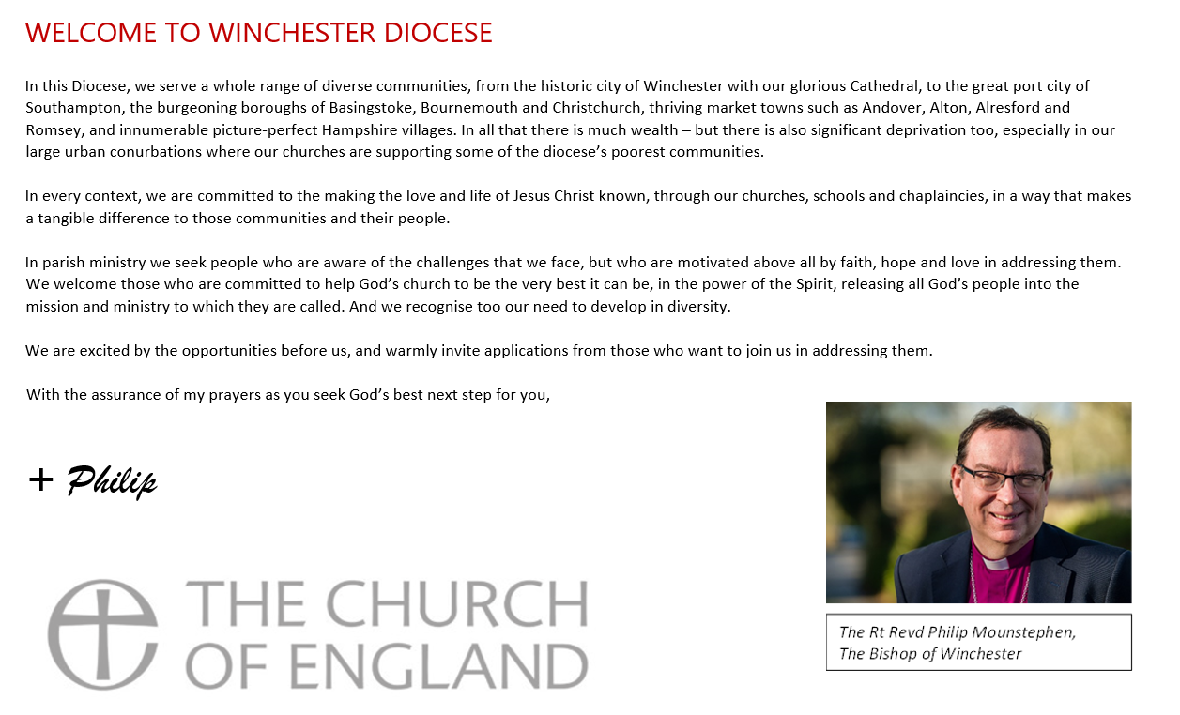

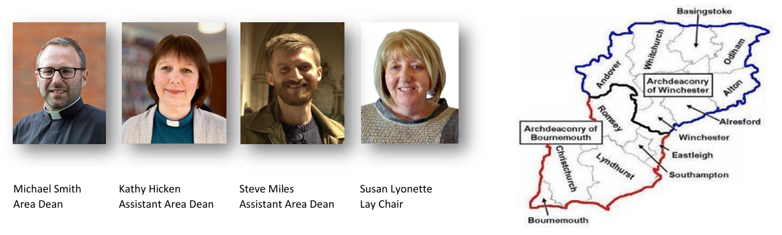
Welcome to Christchurch Deanery
Our Deanery covers an area that includes parts of the New Forest and the English Channel coast. We are grouped into 7 benefices with 26 churches. Our Benefices range from single parishes with one church to Benefices with multiple parishes and churches. These range from suburban, through small towns and large villages to tiny hamlets. Our Deanery is characterised by a supportive and collaborative environment, where clergy are encouraged to share ideas and resources, fostering a sense of belonging and teamwork. We value and respect the variety of theology, spirituality and ways of being Church which is evolving and growing as we work together to live and serve the mission of Jesus. The Deanery Synod meets three times a year and is another great opportunity for you to be part of a lively community, sharing in the mission of Jesus in our wonderful area. We are focussed on supporting the mission of the parishes and building cooperation between our parishes. We have a link with Kinkiizi and share a Lent project across the Deanery each year to support a shared project with Kinkiizi. The Chapter is friendly and supportive, bringing an emphasis on prayer, and practical support and encouragement of one another, we encourage all our clergy to play an active role in the life of the Deanery. Although we have had a number of changes to our deanery clergy and continue to build our Chapter, we have a strong willingness to support our clergy and their families in the demands of ministry. We know that Christchurch Deanery is a great place to live and minister as together we seek to join with our Bishop in “Walking the Wessex Way”. We look forward to meeting and talking with you, as you consider joining our Deanery.

Welcome to THE Parish of Christchurch profile

Thank you for choosing to read our Parish Profile. We are looking for a new Vicar who will guide and work with us to discover where God is leading us.
Currently our Associate Priest (Interim Vicar) with his clergy team, and a very large team of volunteers, have been working closely together to support the parish and helping us grow numerically.
We consider ourselves to be a lively, active, caring, inclusive and welcoming fellowship, expectant and looking forward positively in preparation for our next phase of living God’s mission.
Our prayer is for the Grace to discern who God is calling to serve here. We are praying for someone who can lead with energy, vision and enthusiasm, so that together we can deliver God’s plan for us as we share in His love and serve our community. We also pray that our new Vicar will work with us to help address the financial difficulties that we are currently experiencing.

The Parish Mission and Vision

Our mission and vision are for a:
Life of Worship enabling:
- People to come to a relationship with Christ and as His disciples to be learning and growing in faith
- A prayerful, Spirit-led church
Life of Love striving to grow more to:
- Be a parish where all people feel welcome
- Be a place where love is shown practically within the fellowship and in our wider community
- Have a servant attitude and approach to loving in all our dealings with each other
Life of Service going further to:
- Be good and generous stewards of the resources God has given us
- Work with other churches and local organisations to further the well-being of the wider community
The mission and the vision of the parish are centred on the principles of “HeartEdge” - Congregation, Compassion, Culture and Commerce.

Is this the Parish for you?

We are praying to God for someone who will work with us as a priest, pastor, friend and leader.
A Priest for whom the Eucharist and Daily Offices are the core of their spirituality, and who would honour, respect and develop our choral tradition as well as helping us to explore new styles of worship.
A Pastor who will love the people here, and in loving them, will preach and teach the Faith in sermons and study groups and in their life among us. We trust that our new Vicar will value working collaboratively, not only with colleagues who hold the Bishop’s licence, but also with the “army” of volunteers. We have many talented and faith-filled members of our congregation who we hope our new Vicar will encourage to explore the meaning of the word “vocation” in their lives.
A Friend and Leader with good leadership experience and skills for our large and complex parish, who recognises that friendship was part of the leadership model that Jesus gave us in His relationship with His disciples. We know we are on a journey, and we pray that our next leader will excite us as they lead us on that journey – a journey that is about worship, mission and ministry, but we hope will also include laughter and camaraderie.
Is this the parish for you? If you think it might be – read on!!
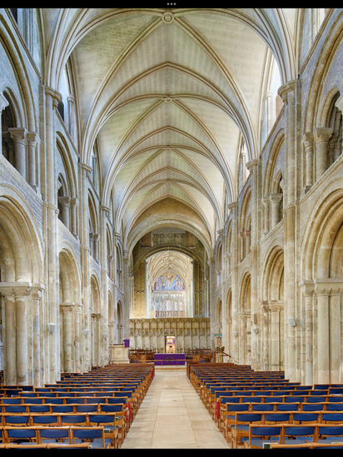
The church buildings in the Parish
The parish has 3 churches.
Christchurch Priory dates back to the 11th/12th century, surviving the reformation largely intact. The Priory is bigger than many cathedrals and is a place of pilgrimage. It is a Grade 1 listed building which attracts large numbers of visitors each year (70,000 in 2025). It is a much-used concert venue for both internationally renowned and local orchestras and choirs.
At the Priory, excellent choral music is a vital ingredient in our worship and is greatly valued by all. It is the go-to venue for civic worship, hosting the annual Mayors Civic Service as well as national commemorations.
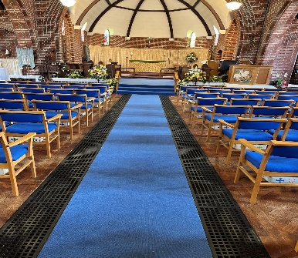
St George’s Church at Jumpers was built in 1927. It is a community-centred church and so is a natural venue for events like Parish Messy Church held once a quarter. Beside the church is a church hall (the only 1 in the parish). It is widely used for events/groups like The Three Bears Day Nursery, Brownies, Guides and dance classes.
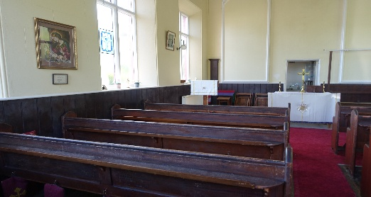
St John’s Mission Church situated in Purewell was built in 1880. It is a small church which is currently used by All Saints Church, Mudeford for midweek services. Its long-term future, as an asset for ministry and mission in that part of the parish, is an issue that we look forward to working on with our new Vicar.
The schools in the Parish

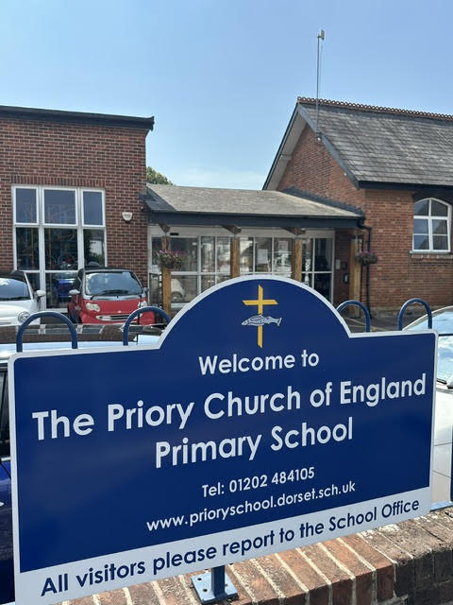
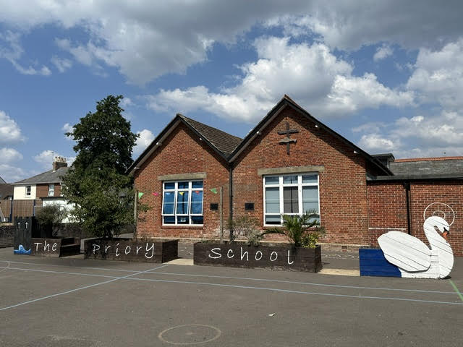
The parish has close links with the Priory Church of England Primary School, with the Vicar being an ex-officio Governor and the PCC appointing Foundation Governors when required. The clergy lead collective worship once a week and the school holds services twice a term in the Priory Church. We regularly have pupils, teachers and parents visiting the Priory for services and other events.

We also have links to other schools including Twynham School, The Grange School and Christchurch Junior School.
Every year we hold a junior school leavers day, where the Priory welcomes in excess of 600 children from many local schools for crafts and music, culminating in a service of worship. Our hope is that our new incumbent would foster and increase these links.

Children and Families
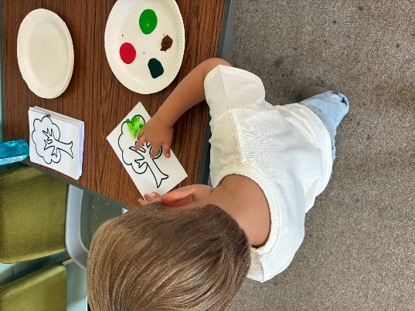
We have a desire to increase the number of children and families involved in parish life. While we recognise the strength of numbers of children in the choir (36), we would also like to attract more young families to our services. We aim to grow Junior Church, use St George's more, and increase contact with other local schools.
For several years we have been a placement parish for Moorlands College students, and in the past 3 years we have been able (thanks to a generous benefactor) to employ a Children and Families Worker. Sadly, this funding has just finished, so from September, we will be looking for a team of volunteers to continue this ministry.
Junior Church crafts


Children and family activities currently include:
- Weekly Parents and Toddlers group in Priory House
- A new Messy Church at St George's
- Weekly Junior Church at the Priory during term time
- Open the Book team at the Priory School
- Weekly boys and girls choir rehearsals at the Priory

Volunteers
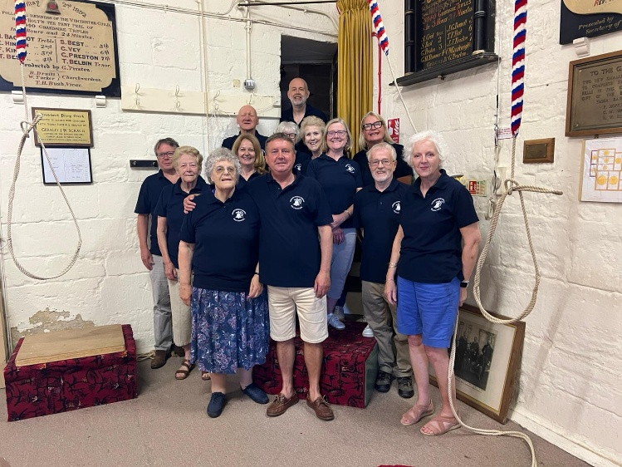
The parish is blessed with a large “army” of volunteers (currently 220 people) and we are very grateful for the work they do. We have all the usual volunteer roles that you would expect to find in an active parish including sidesmen, lesson readers and intercessors, servers and Sacrament distribution assistants, refreshment providers, holy dusters, flower arrangers, and bellringers (we have a 13-bell tower with a peal of12).

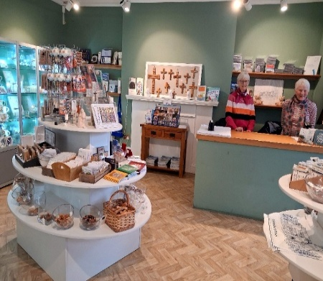
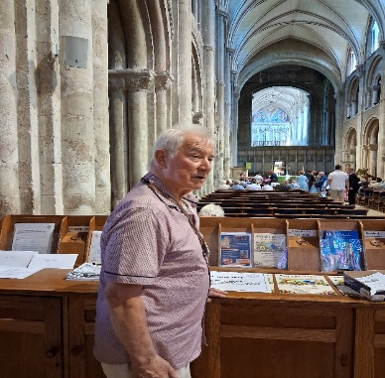
Due to the history of the Priory, and being in a tourist zone, we are staffed daily by welcomers, guides and stewards. Volunteers also staff our shop and museum, and some assist in the tea room.

Our Organisation

The daily administration of the parish is conducted from Priory House by paid staff. We have found it necessary to have paid staff because of the size and complexity of our operation. This is directed by the Chief Operations Officer who reports to the Senior Staff Team (SST). Strategic decisions are, of course, made by the PCC who currently meet monthly.
The PCC employs 7 salaried staff, not all full time. The operational hub is at the Priory. A Facilities Manager looks after buildings across the parish, and some properties are let through an agency. Our churches and Priory House are maintained by our facilities team overseen by the SST and the Fabric Committee, in co-operation with our conservation architect and archaeologist.
Funding for our Parish is a challenge, but we have always paid our share of the Common Mission Fund. At the moment expenditure exceeds income. The PCC is well aware of this and is working to address the problem. Christchurch Priory Enterprises Limited (CPEL) employs 5 salaried staff who manage the tea room and the shop. Annual net profit is transferred to the living church. Other major sources of income are events, concerts, and legacies. We are looking forward to maximising these income streams, but also recognise the need to promote new ways of generous giving from the congregation.
We know that communication to our church family and the wider community is key to being a vibrant force for Christ in Christchurch. We use our website, Facebook and Instagram as well as paper bulletins, pastoral letters, posters and, in the Priory, our TV screens. We use Zoom to facilitate the daily Morning Prayer, and we live stream our main Sunday Eucharist service at the Priory via YouTube.
Safeguarding

The Parish of Christchurch is committed to the safeguarding, protection and care of children and vulnerable adults, within the communities of our 3 churches, and also of visitors, employees and volunteers.
We are also committed to implementing the Church of England’s Safeguarding Policy and Procedures, and the relevant statutory legislation, guidance and best practice for the welfare of children, young people and vulnerable adults.
A copy of the Parish's Safeguarding Policy can be found here: Parish Safeguarding Policy

Our Current Team
Parish Churchwardens
Mrs Patricia Richards
Mrs Hazel Baker
Deputy Wardens – St George’s
Mr John Hicks
Mr Jeff Perkins

Clergy and Ministry
Revd Richard Partridge – Interim Vicar
Revd Canon Paul Harris – Retired PTO
Revd Angela Newton – Retired PTO
Revd Canon Graham Newton – Retired PTO
Revd James Robertson – Retired PTO
Revd John Staples – Retired PTO
Revd Carolyn Tibbott – Retired PTO
Mr Will Howard – LLM
Mrs Hannah Hoskin – LLM (training)
Music
Mr Simon Earl FRCO - Director of Music and Master of Choristers
Mr David Beeby FRCO - Assistant Director of Music
Mr Geoffrey Morgan FRCO - Organist Emeritus

Administration and Facilities Team
Mrs Elspeth Sully -
Chief Operations Officer

Mrs Debs Barclay -
Parish Administrator and PCC Secretary

Mr John Puzey – Head of Finance
Ms Becca Shanley - Finance Assistant
Mr Tony Player - Facilities Manager
Mr Paul Saunders and Mr Greg Rolls -
Facilities Team members with verger responsibilities

Mrs Sue Haxby – Parish Safeguarding
Officer (Volunteer)
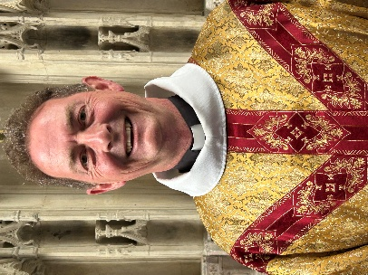
Richard Partridge - Richard trained for ordination at Sarum college. He has held the pastoral care co-ordination role and during the vacancy is serving as Interim Vicar. He loves walking his dogs, eating out with friends and he is learning to play the piano. He would describe himself as a priest pastor who is fed by traditional Choral Worship, especially in the Eucharist and Choral Evensong.
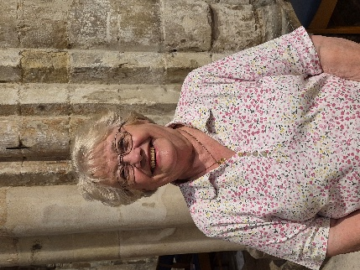
Patricia Richards – Patricia has been a volunteer in the Priory since 2007. She started in the gift shop and later became a guide. Patricia was a Churchwarden from 2012-2018 and has been on the PCC and Finance Committee since then. She has recently been elected as Churchwarden for 2026-2027.

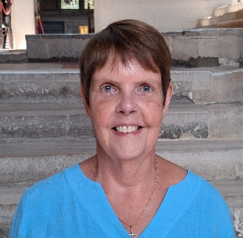
Hazel Baker – Hazel was recently elected as Churchwarden for 2026 - 2027. She has served on the PCC both previously and currently. For many years she has been a sidesman at the Priory. In the past she was a joint leader of the youth group, Tower Bats. She also sings with the Priory Consort Choir. Her career was in national and local government.


Elspeth Sully – Elspeth is dedicated to serving the Parish of Christchurch as its Business Leader, combining a heart for ministry with a mind for stewardship. Drawing on her background in IT, finance, operations and project management, she works to ensure that every resource entrusted to the church is used wisely to advance God’s work. Elspeth has over 30 years’ experience in the not-for-profit, private and public sector areas. She holds a MBA from Liverpool University.
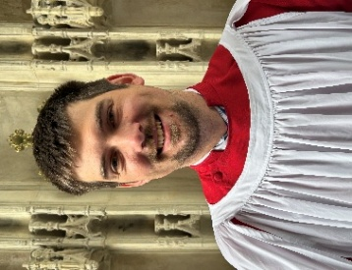
Simon Earl - Simon has been Director of Music since 2015. He is responsible for directing, recruiting and training the Priory’s 5 choirs, and overseeing the other musical activities throughout the year. Before moving to Christchurch, he worked at Guildford, Newcastle and Wakefield Cathedrals.

Foundations for the Future
We have a number of building and conservation projects we would like to undertake. Working with the Heritage Lottery we have already been successful in repairing, conserving and relaying the Nave aisle floor. This was our first project with the Heritage Lottery, and the Project Board are keen to make more progress. Foundations for the Future is focused on the following areas:
- Visitor Engagement
- Accessibility
- Audience Development
- Mechanical & Electrical consultancy to guide the parish towards net zero carbon
- Environmental monitoring for the Nave roof in preparation for repair (underneath are nationally important medieval paintings on the roof support beams)
- Nave roof beetle study (see bullet point above concerning the medieval paintings)
The PCC have prioritised a wish list of projects and will complete them in “bite-sized chunks.” This plan is welcomed by the parish and the Heritage Lottery. Altogether the projects formulate the Masterplan for which we are raising funds. The major project is the anticipated creation of a new multi-purpose community centre and museum/heritage learning centre which would link the church to the community and tourism, and to help secure an enhanced income.

Finance
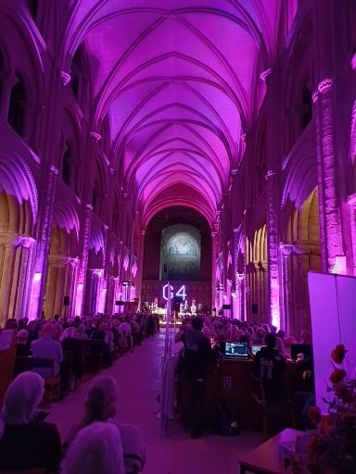
Like so many other parishes the cost of living is having an impact on the income of our living church; therefore, we are maximising our sources of income, including using the Priory as a venue for concerts and events.
We continue to explore suitable commercial activities to increase the income for the parish. We also let some properties and land. The majority of income generated from these rentals is legally restricted to use on conservation of the Priory and Priory House and is not available for day to day (living church) costs.
A full set of accounts including Funds and Trusts can be made available upon request.
In the following consolidated statement of financial activities for the End of Year Accounts 2025, the donations and legacies shown within the unrestricted funds figure of £1.27 million was an unexpected gift of a very generous legacy.
A detailed Parish Business Plan is available on request.
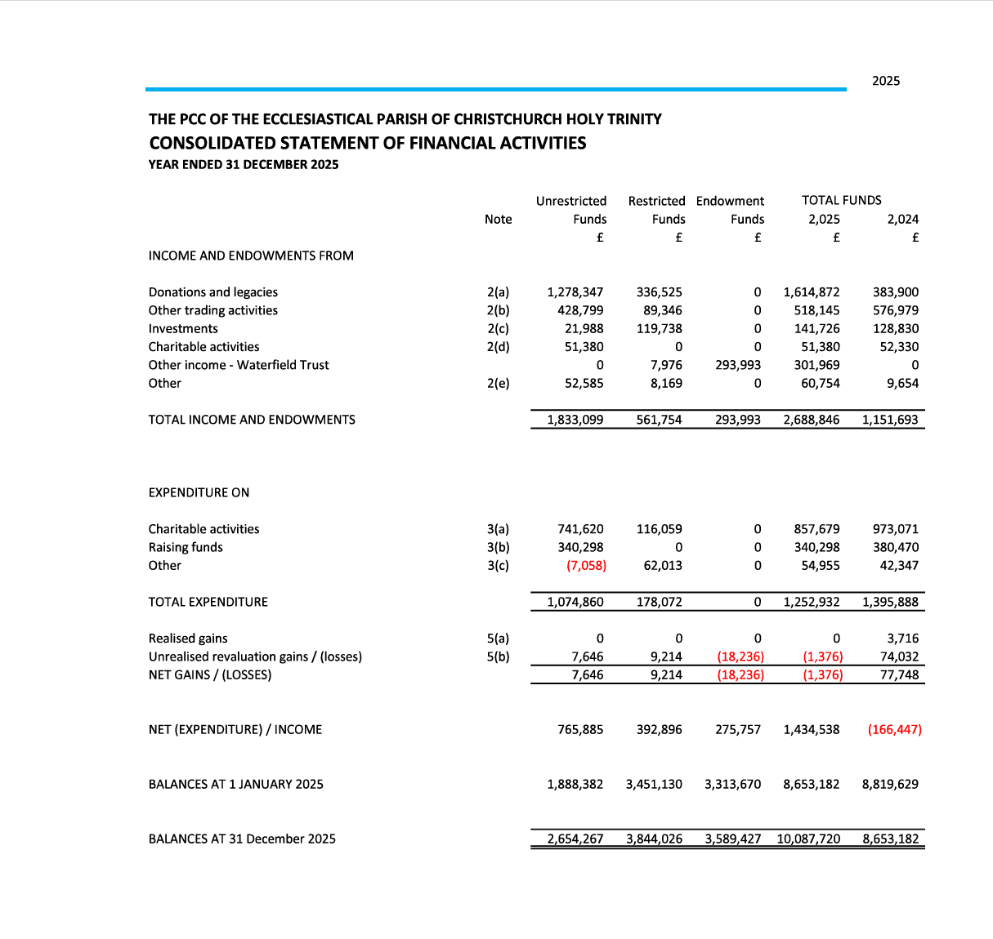
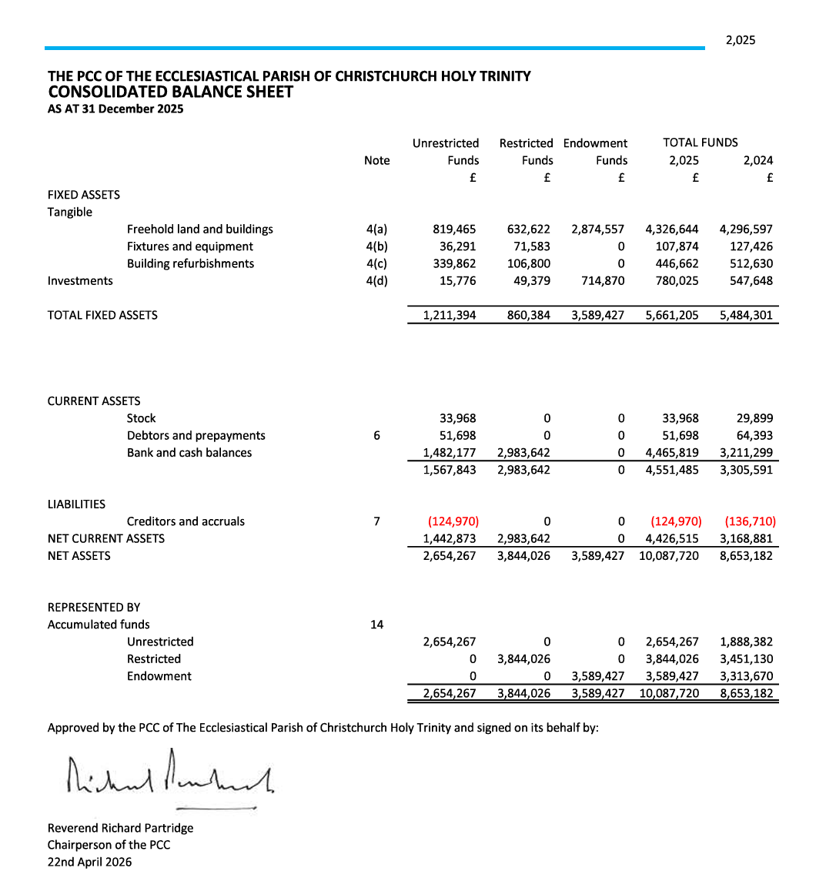

Our Church Life
Governance
The parish is governed by a single PCC, with the Finance Committee, the Fabric Committee and a Project Group reporting specific activities. The clergy team currently consists of an Interim Vicar (Associate Priest) and Licensed Lay Minister. They are supported by a team of retired clergy. Operational management of the parish is headed by the Chief Operations Officer who is responsible for a team of salaried staff and many volunteers.
The last full revision of the Electoral Roll took place in 2025 and currently stands at 226 members.
Across the parish we offer a variety of services including daily Morning Prayer via Zoom, Evening Prayer, Sung Eucharist and Choral Evensong on Sundays. During Advent 2025 the Priory held:
- Darkness to Light service
- Local School Carol services
- Christingle service
- 4 showings of The Snowman film with live orchestra, narration and chorister soloist
- 2 Crib services
- 2 Nine Lessons and Carols services
- Midnight Mass
The total attendances over this period were 6880.

Similarly, a series of special services are held during Lent, Holy Week and Easter.

Fellowship and outreach are offered through coffee after all main services at both churches.
St George's also holds regular seasonal fellowship lunches.

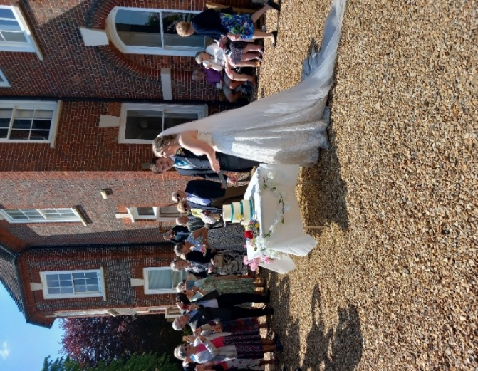
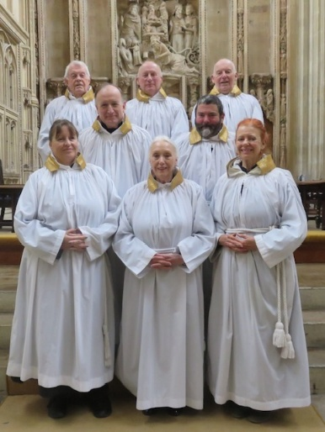
Alongside the team of retired Clergy, a LLM and another LLM in training, there is a strong lay support group.
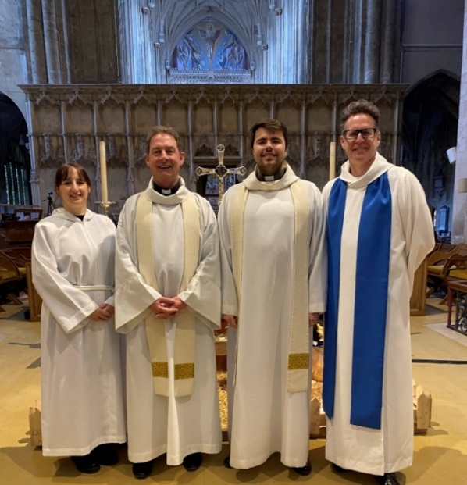
Clergy team as at the beginning of June 2026. A wedding at the Priory. Servers at the Priory.
We said farewell to our Curate Sam at the end
of June.

Confirmation courses and services are held annually. We had 10 confirmation candidates in 2025. The group have joined in parish life wholeheartedly and we would like to build on this success. We have 11 candidates for confirmation in October this year.
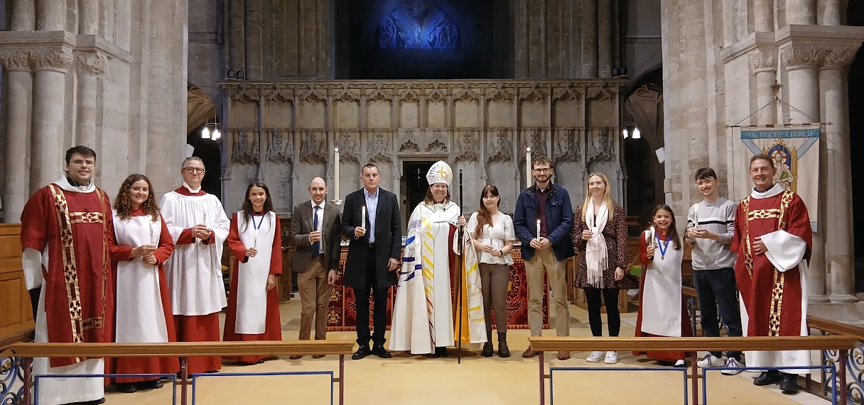

The Priory is traditionally the Civic Church for Christchurch, and there is an annual Civic Service. The Vicar is the current Chaplain of Christchurch Town Council and also Chaplain to the Royal British Legion Christchurch Branch.
Our worshipping communities
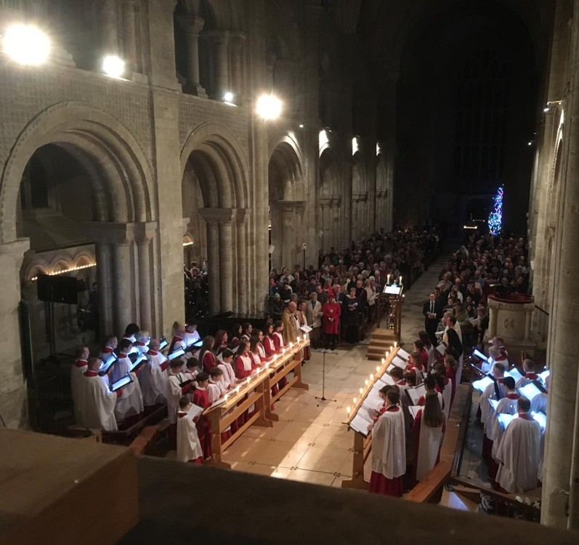
The Priory
Sunday:
8am Said Eucharist (Book of Common Prayer).
10am Choral Sung Eucharist (Common Worship, Order 1).
Baptism(s) follow this service when required.
6pm Choral Evensong (Solemn Evensong and Benediction with incense on the last Sunday of the month).
Monday and Tuesday: 9.30am Said Eucharist
(Common Worship, Order 1).
Wednesday: 11am Said Eucharist with Hymns (Common Worship Order 1). Once a month this includes the Sacraments of Healing.
Thursday: 11am Said Eucharist (Book of Common Prayer).
Monday to Saturday: 8.30am Morning Prayer by Zoom.
Monday to Thursday: 4pm Evening Prayer in the Great Quire.

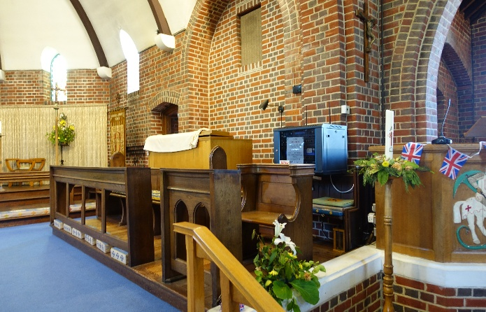
St George’s
Sunday: 9.30am Sung Eucharist (Common Worship Order 1).
Thursday: 10am Said Eucharist (Common Worship, Traditional Language).

St John’s
There have been no regular services since the Covid pandemic; however, All Saints Mudeford are using it for their midweek Eucharist while they rebuild. The future development of use of St John’s is still to be decided.

During 2025 the parish life events consisted of :
Weddings – 22
Baptisms – 36
Funerals – 31
Interments in our Garden of Rest – 54

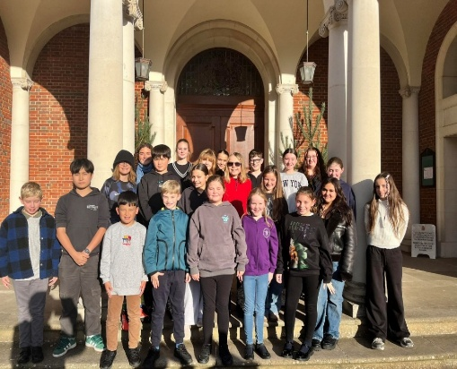
Music at the Priory
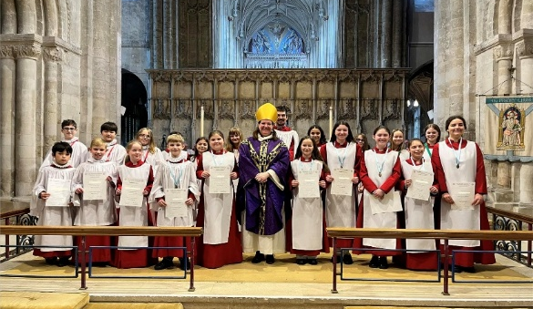
The Priory has a strong choral tradition led by our Director of Music who runs our choirs. The regular choir is made up of choristers (aged 7 to 18) who are supported by many adult voices. The Chamber Choir is a mixed adult choir made up of accomplished and experienced choral singers. The Consort Choir is open to all who enjoy singing together in a group.
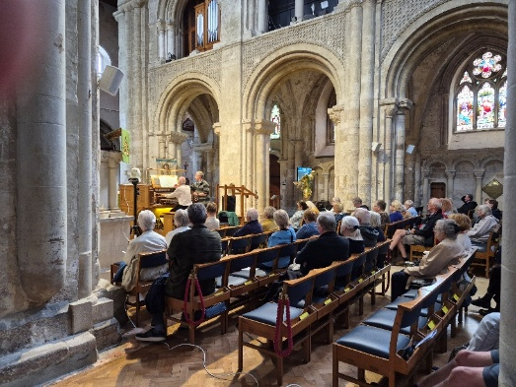
The Priory has one of the finest church organs in the South of England with over 4500 pipes, built by Nicholsons in 1999.
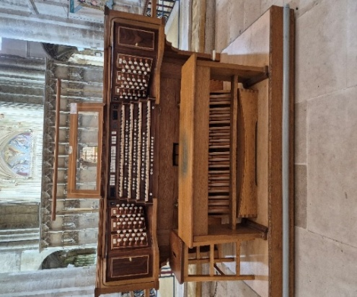
Major musical events include:
- Well attended weekly organ recitals led by our
3 and visiting organists
- Week-long Music Festivals are held usually every
2 years
- Choir tours (have included Belgium, Italy and
Spain)
- 'Come and Sing' Events (including Stainer’s Crucifixion)

Other activities in the Parish

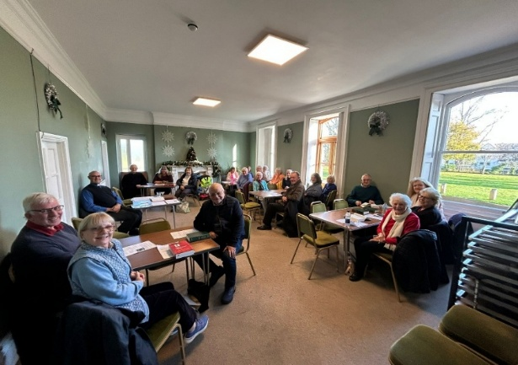
Include:
- Well attended parish Bible study and discussion groups
- A sight-loss friendly church initiative (St George's)
- Parish Summer and Christmas Fetes
- The Friends of the Priory, which financially supports the repair,
conservation and improvement of the Priory
- Monthly coffee mornings (St George's)
- Mothers Union

A Study Group

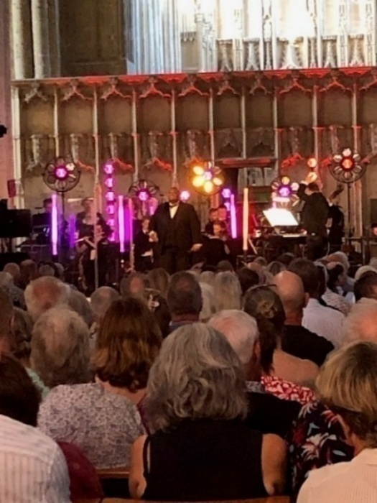
The Priory is used as a concert venue on a commercial basis by professional and amateur musicians and choirs including the Bournemouth Symphony Orchestra and Chorus. We are constantly exploring opportunities to widen audience appeal, and the Priory has recently become a venue for Tribute Artists.

Online presence:
https://www.christchurchpriory.org/
https://www.instagram.com/thepriorychurch/
https://www.facebook.com/ChristchurchPriory/
https://www.facebook.com/christchurchpriorychoir/
https://www.youtube.com/channel/UCsULNt9Ud07dBEb0RM3Bknw
https://friendsofchristchurchpriory.org.uk

Commercial Enterprise
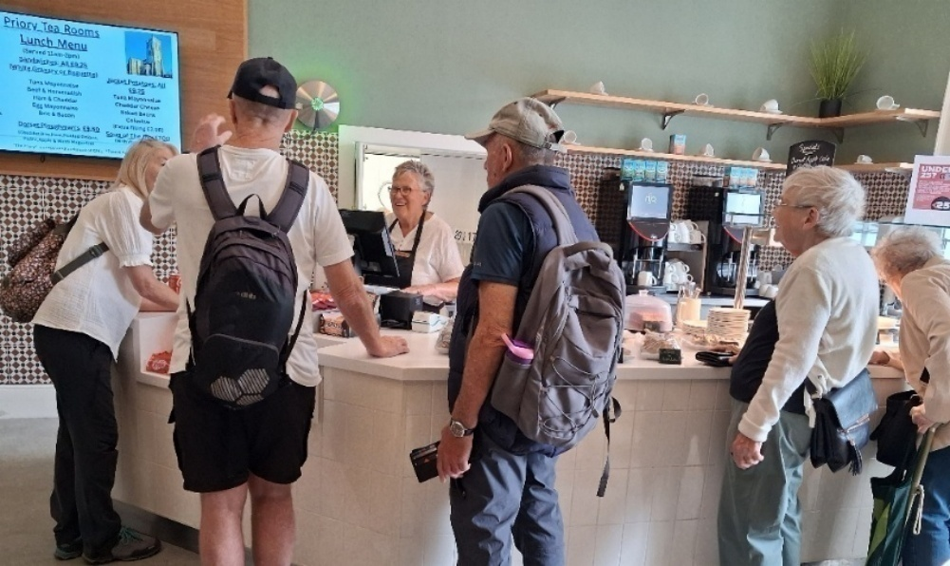
The tea room and gift shop are both located in Priory House, which adjoins the church. This commercial enterprise, known as Christchurch Priory Enterprises Limited, is run in accordance with the ethos of “HeartEdge”. It is a separate limited company generating profit. The tea room provides a safe space and friendly environment for those who wish to purchase drinks, cakes and light snacks. Customers also benefit from being able to sit and enjoy their refreshments on the monastic lawn, when weather permits.
As a parish, we want to continue to be a blessing and a gift to the wider community that is Christchurch, and to visitors and holiday makers coming to our town.
Our new Vicar will have proven experience in leading a large team of staff and volunteers and can demonstrate his or her collaboratively with such a team, and to enable others to utilise their own gifts and life experiences more fully.

The House

The Vicarage, 13a Church Street, Christchurch, BH23 1BW

Currently let as part of the management of the Diocese’s property portfolio.

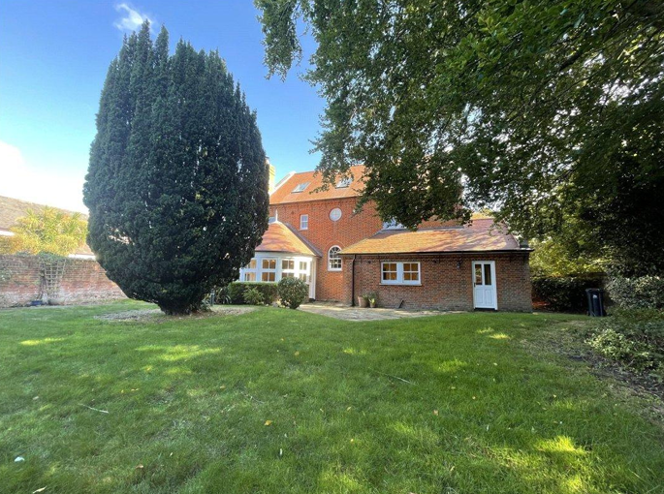
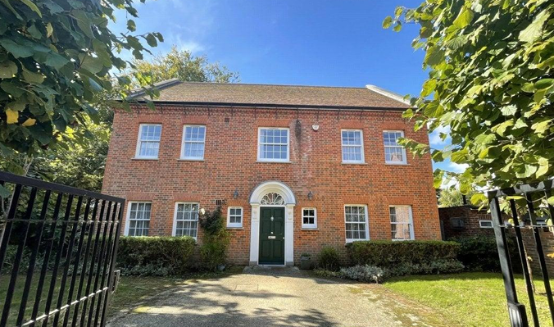
THE VICARAGE
Front
Rear

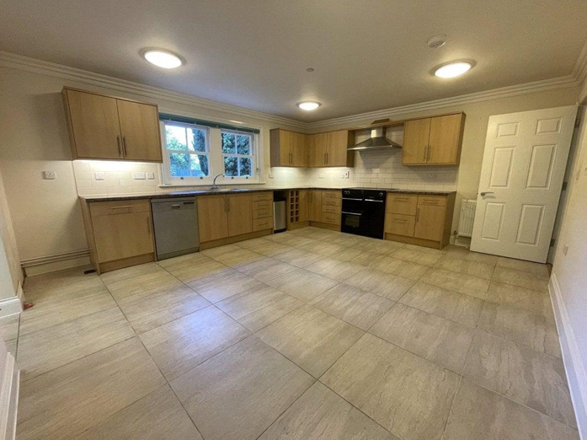
The Vicarage is a modern three-storey detached home offering generous and flexible accommodation. The ground floor has two good sized reception rooms plus a dedicated study which is separate from the living accommodation. There is a large open kitchen and a separate utility room. The first floor has four bedrooms and two bathrooms (one an ensuite serving the principal bedroom). The second floor has two additional bedrooms. Outside there is a garage, extensive garden, and off-road parking for three cars. The house is across the churchyard on Church Street in the historic heart of Christchurch. The setting offers a blend of heritage surroundings, riverside walks, and excellent access to the town’s shops, cafés, and good transport links including a railway station within half a mile and is also quite close to Bournemouth Airport.
Kitchen
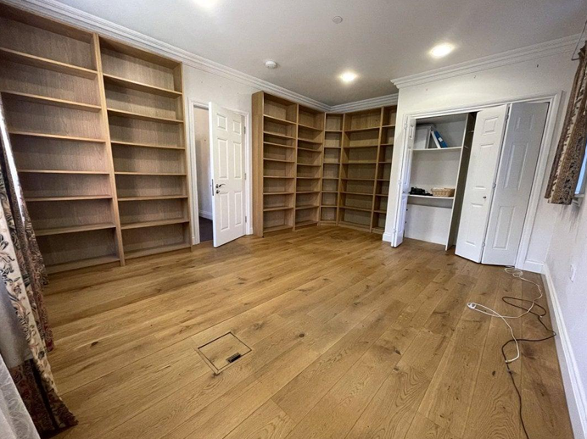
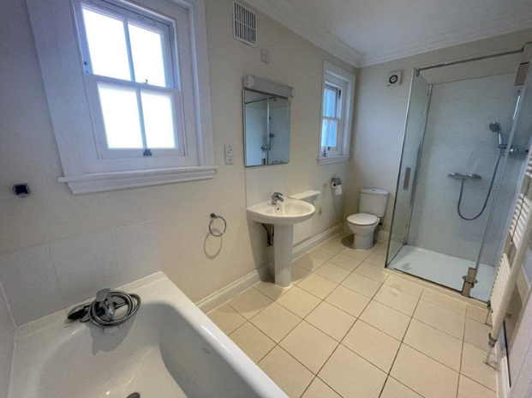
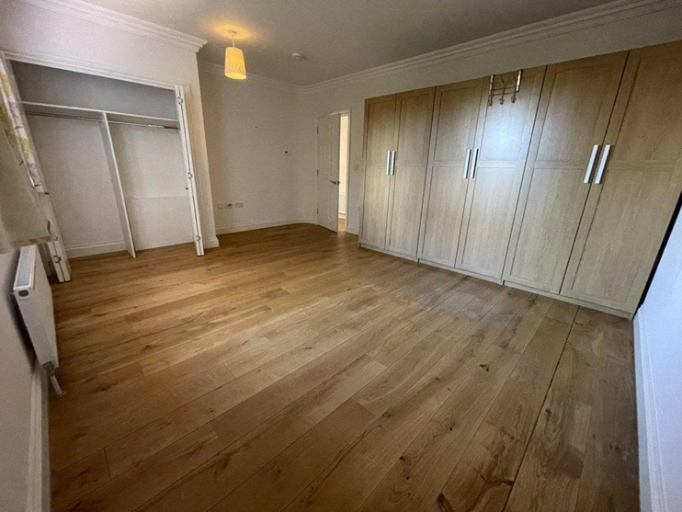

Study
Bathroom
Bedroom

HOW TO APPLY
A full application pack, along with Terms and Conditions, is available from the Diocesan website here.
For an informal conversation about vacancies in the Bournemouth Archdeaconry please contact:

The Rt Revd Rhiannon King Ian Parker
The Bishop of Southampton on 01962 737315 Clergy Appointments Assistant 01962 737310
Bishop.rhiannon@winchesterdiocese.org clergy.appointments@winchesterdiocese.org

‘From his fulness we have received, grace upon grace’
John 1: 16

Diocesan Office: Old Alresford Place, Old Alresford, SO24 9DH
T: 01962 737310
W: winchesterdiocese.org
https://www.instagram.com/cofewinchester/

