[CHURCH NAME]

A prayerful invitation to reflect on our giving

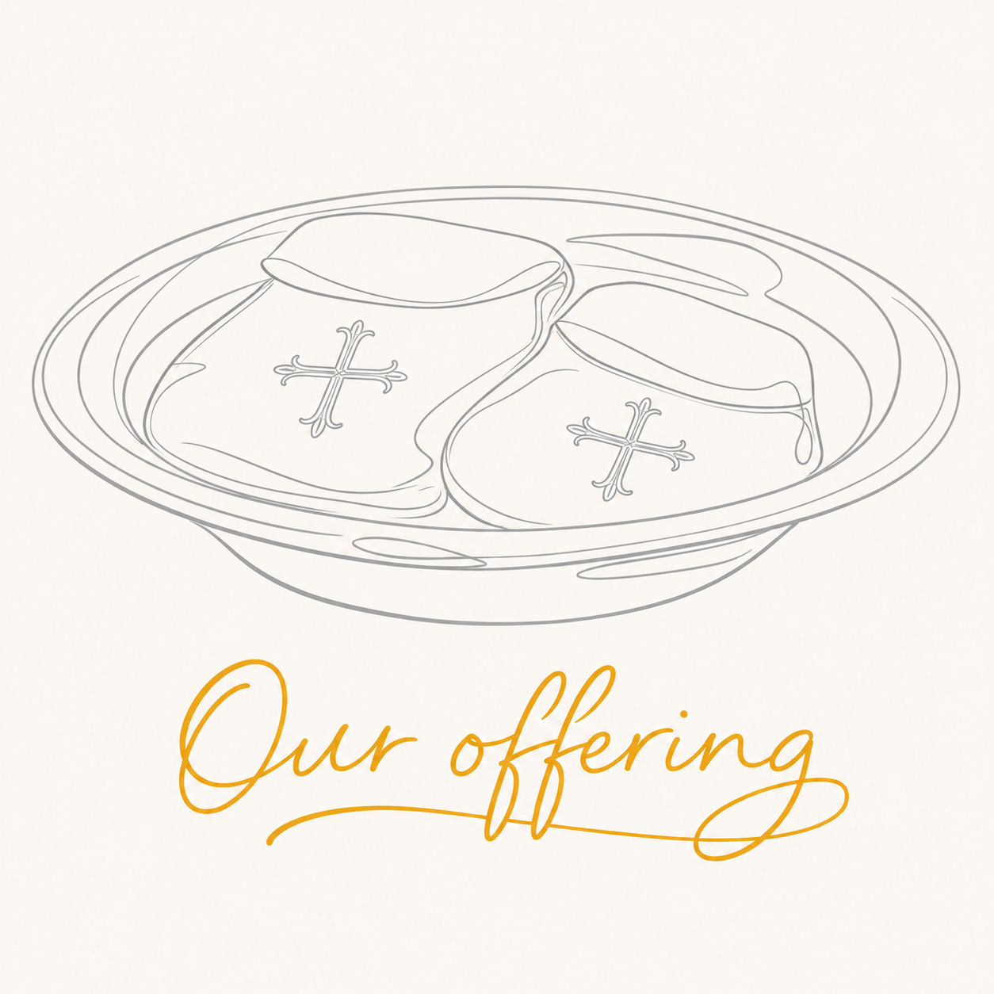

Our Offering
At the offertory, the gifts of God’s people are brought forward. Whether we give through the plate, by envelope, standing order, online, or through the Parish Giving Scheme, our money represents part of our lives. It comes from the work we have done, the resources entrusted to us, and the choices we make about what matters most.
Our giving does practical things. It sustains worship and ministry, cares for our church building, supports service in our community, and contributes to the life and mission of the wider Church.
But Christian giving is more than meeting expenses. We give because God has first given to us. Our financial giving and volunteering are ways in which we respond to God’s generosity and offer ourselves for his service.
Throughout Our Offering everyone is invited to pray about their giving. Some may decide to begin giving regularly. Others may be able to increase their gift. Some will faithfully continue at their present level.
The amount will differ for each person and should be appropriate to their circumstances. What matters is not simply the amount, but the offering of the heart.
Please take this booklet home and return your completed response by [DATE].
We know that some in our church family are facing real financial pressures at the moment. If you are unable to contribute more, please be assured that you are no less valued. Offering our time, skills and prayers is also vital to our shared response to God’s generosity, and we are deeply grateful for every way you can contribute.

Our Offering
If possible, please return your confidential response by [DATE].
Church:
Name:
Phone or email:
After prayer and reflection, please tick any boxes that apply:
☐ | I intend to begin regular giving.
☐ | I intend to change my regular gift to:
 | Amount: | £ ____________________
 | Frequency: | ☐ week ☐ month ☐ quarter ☐ year
☐ | I have reviewed my giving and will continue at its present level.
☐ | I have already made the change directly through my bank or giving provider.
INFORMATION AND OTHER WAYS TO OFFER
☐ | Please give me information about the Parish Giving Scheme.
☐ | Please give me information about standing orders or other ways of giving.
☐ | Please get in touch with me about Gift Aid.
☐ | I would welcome a confidential conversation about giving.
☐ | I would like to explore offering time or skills in the life of our church.
☐ | Please get in touch with me about possible ways to volunteer.
Date:
Thank you!
Thank you for taking part in Our Offering and for reflecting prayerfully upon your giving.
Every gift helps sustain the worship, ministry and service of our church. More deeply, every willing gift is part of our shared response to God’s love and generosity.
Where you have asked for information or assistance, [Name] will contact you confidentially.
Whatever your response has been, thank you for your part in the life of [Church Name] and for all that you offer to God and to our community.
‘All things come from you, and of your own do we give you.’
(1 Chronicles 29.14)

Returning your response
Please return this booklet in the envelope * provided to [Name/Role] by [Date].

Please do not enter bank or card details on this form. The information you provide will be used only to respond to your request and administer your giving.

