


Easter Activities for Early Years

Why it is important celebrate Easter in EYFS
The religious significance of Easter is clearly hugely important in Christianity and, as such, it is appropriate that this is valued and recognised in our Church of England pre-school settings.
Understanding the meaning and reality of the death and resurrection of Jesus is clearly difficult for very young children, but the sadness of loss can be understood, and the joy of celebrating life and happiness in communities is important.
Studying the Easter story helps young children understand the world, including other cultures and traditions. Below are a range of activities to help children in our nurseries. Each one relates to something that the children can learn about the Easter story in an age-appropriate way.

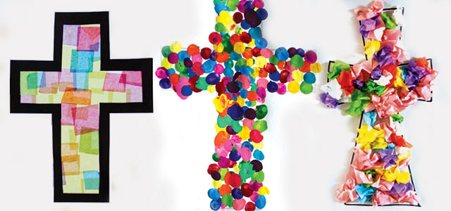

Easter is also an opportunity to demonstrate inclusivity, including all religions, economic backgrounds and disabilities in the celebrations. When preparing Easter craft ideas in EYFS, there are endless sensory play and tactile exploration possibilities. Children can be encouraged to develop their confidence with different textures and materials whilst working on increasing independence levels. These activities are linked to the 7 Areas of Learning to help settings.
To begin, read the Easter story to the children. Suggested books are below. Point out the cave that Jesus was put into and explain that it was sad. Then, tell the children how happy he and his friends were when he came out from the cave.

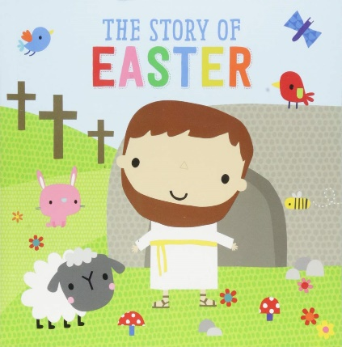
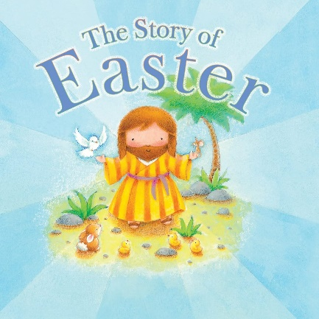
Tell the children that you have some new activities for them to remember Jesus as a special friend who wanted us to be kind to everyone. Explain that Easter is a time when we give eggs to each other because it reminds us of the cave and because it is a kind thing to do. Jesus would like that we do this.

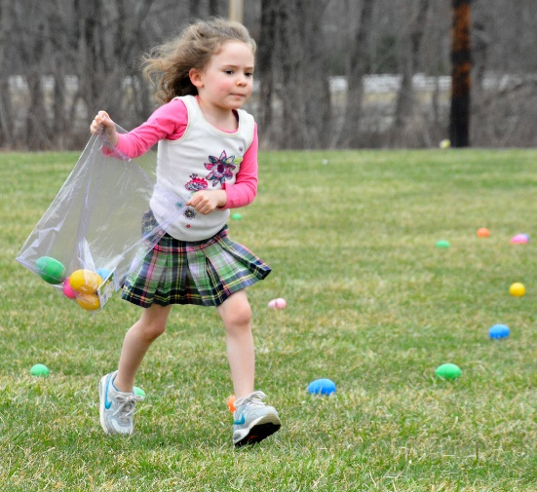
Easter Egg Hunt
Setup:
Set up an interactive Easter Egg Hunt by hiding eggs throughout a designated space, indoors or outdoors. Consider incorporating simple clues or visual cues to help toddlers locate the eggs.


You may like to remind children of Jesus’s message to be kind to other people and say that they should find one egg for themselves and one for someone in their family.

Learning Benefits:
Gross Motor Skills Development: Engaging toddlers in an interactive Easter Egg Hunt promotes the development of gross motor skills as they move, walk, or run around to search for hidden eggs. This physical activity contributes to their overall coordination and motor skill refinement.
Cognitive Stimulation through Problem-Solving: The inclusion of simple clues or visual cues during the egg hunt encourages toddlers to engage in problem-solving. Figuring out where the eggs are hidden stimulates cognitive processes and enhances their ability to make connections.
Sensory Exploration: The use of a variety of colours and sizes for the hidden eggs adds a sensory dimension to the activity. Toddlers can explore and differentiate between the visual stimuli, enhancing their sensory awareness.
Independence and Decision-Making: Encouraging toddlers to explore and discover the hidden treasures independently or with guidance promotes a sense of independence. Making choices about where to search for eggs and deciding on the best approach fosters early decision-making skills.
Social Interaction and Language Development: If done with others, the interactive Easter Egg Hunt provides an opportunity for social interaction. Collaborating with peers or caregivers to find eggs promotes positive social experiences, and discussions about the hunt contribute to language development.

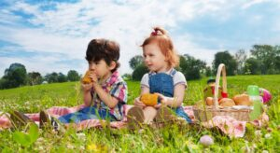
Egg Bowling
Setup:
Set up an egg bowling game using plastic eggs as pins and a small ball for rolling. Designate a bowling lane and encourage toddlers to take turns rolling the ball to knock down the egg pins.

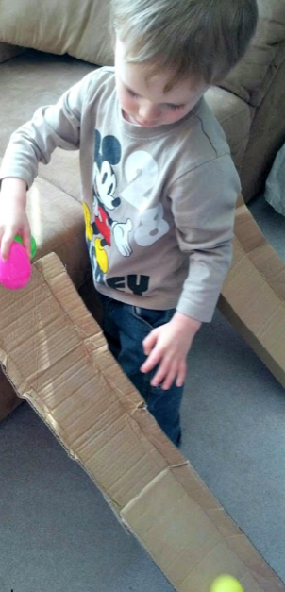

Wobbly Easter egg race
Make a ramp using some recycled cardboard. Fold up the sides so that the eggs cannot leave the ramp prematurely. Set up two cardboard ramps using a sofa or chair to lean against.
Get the children to race their eggs to the ground.

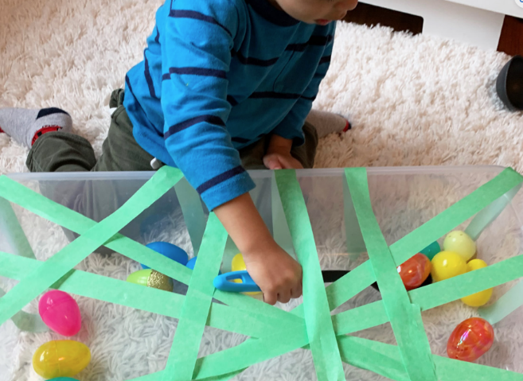
Easter egg rescue
You will need: Plastic Easter eggs, masking tape or paper strips, a large plastic box and a soup ladle or large spoon.

- Tape the paper strips or use the masking tape to make a web across your box. (You can use a cardboard box, laundry basket or any container that will hold the eggs!)
- Place the eggs in the box.
- Use the soup ladles or cooking spoons beside the box for children to use to try bringing the eggs through the web and out of the box.

Learning Benefits for the above activities:
Gross Motor Skills Development: Setting up an egg bowling game involves rolling a ball to knock down plastic egg pins, promoting the development of gross motor skills. Toddlers engage in movements such as rolling and throwing, enhancing their overall coordination and motor skill refinement.
Hand-Eye Coordination Improvement: Participating in the egg bowling game requires toddlers to coordinate their hand movements with their visual perception. Rolling the ball with precision to knock down the egg pins enhances hand-eye coordination, a crucial skill for various activities.
Social Interaction and Turn-Taking: The game format encourages social interaction among toddlers. Taking turns rolling the ball and cheering for each other fosters a sense of camaraderie and promotes turn-taking skills, contributing to social development.
Cognitive Stimulation through Aim and Accuracy: Engaging in the egg bowling game stimulates cognitive processes related to aim and accuracy. Toddlers learn to judge distances, adjust their aim, and observe the outcomes of their actions, fostering cognitive development in a playful context.
Enjoyable Physical Activity: The egg bowling game provides an enjoyable way for toddlers to engage in physical activity. The combination of rolling a ball and knocking down egg pins adds an element of fun to the experience, promoting an active and positive attitude towards physical play.

Planting seeds
Using an Easter storybook, show the children the picture of the garden where Jesus was reunited with his friends. Let them plant Easter flowers.
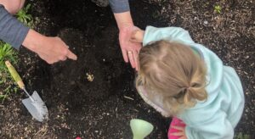
Setup:
Set up a seed planting station with a variety of seeds, small pots, and child-friendly gardening tools. Demonstrate how to plant seeds, and let the children take charge of the process with minimal assistance.

As the seeds grow into plants, track the growth with the children and discuss more about how beautiful God’s world is.

Caterpillar seed heads

You will need:
- Egg cartons
- Paint and paint brushes
- Pipe cleaners
- Googly eyes
- Glue
- Cotton wool
- Sprouting seeds, such as cress, mustard, dill, coriander, rocket, radish
Cut an egg carton in half and paint. Using a pencil, poke holes into each segment and thread pipe cleaners through, to make legs. Glue on some googly eyes before stuffing each segment with cotton wool. Sprinkle each segment lightly with seed.

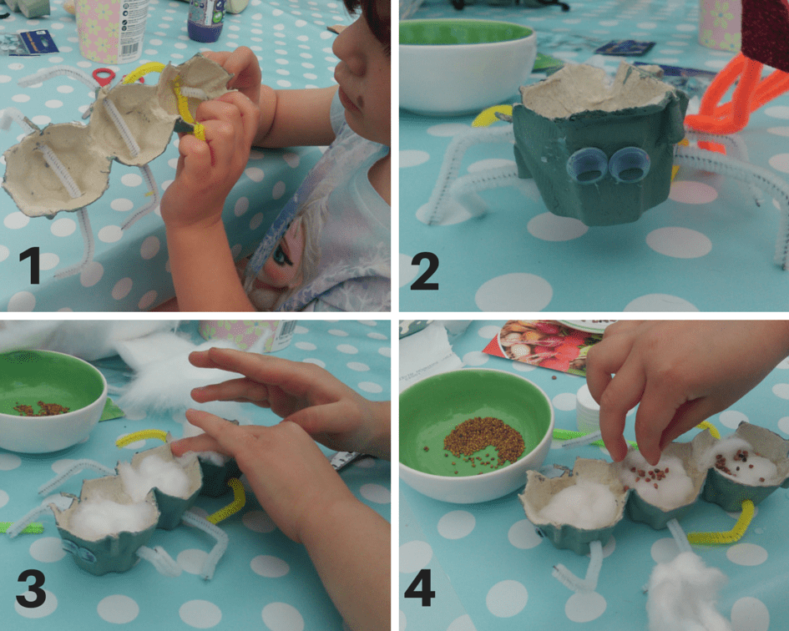

Place on a warm windowsill and watch the magic happen. The seeds should sprout within three or four days. caterpillars well-watered.
Learning Benefits:
Fine Motor Skills Development: Engaging toddlers in a seed planting activity with child-friendly gardening tools promotes the development of fine motor skills as they manipulate seeds, pots, and tools. This hands-on experience encourages precise movements and finger dexterity.
Cognitive Stimulation through Hands-On Learning: Participating in the seed planting process stimulates cognitive development as toddlers learn about the plant lifecycle through hands-on experience. Observing the seeds grow into plants fosters an understanding of cause and effect and introduces basic concepts of biology.
Sensory Exploration and Nature Connection: Handling seeds and soil offers sensory exploration opportunities, connecting toddlers with nature. Feeling the texture of seeds and soil enhances sensory awareness and fosters a deeper appreciation for the natural world.
Promotion of Independence and Responsibility: Allowing toddlers to take charge of the planting process with minimal assistance promotes independence and responsibility. Taking ownership of caring for the planted seeds instils a sense of pride and accomplishment in toddlers as they witness the growth of their plants.
Environmental Awareness and Eco-Literacy: Engaging in seed planting introduces toddlers to environmental concepts and fosters eco-literacy. Discussing the plant life cycle and the importance of caring for plants promotes environmental awareness and encourages a sense of responsibility towards nature.

Spring Picnic

Tell the children that at Easter Jesus went to a lake and had a special picnic with his friends.

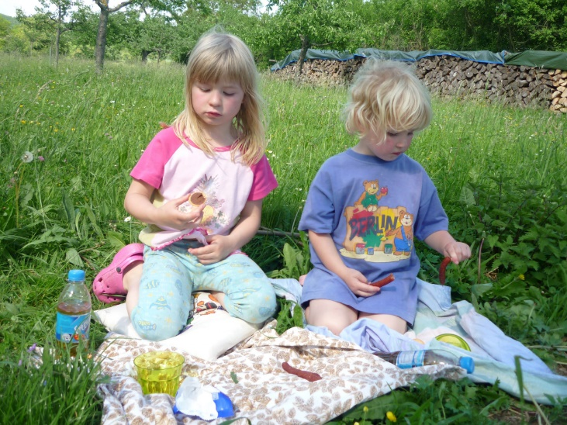
Setup:
Organise an outdoor spring picnic with toddler-friendly snacks. This could be in your nursery garden or at the local park. Spread out a picnic blanket and encourage toddlers to sit, eat, and enjoy the surroundings.
Learning Benefits:
Social Interaction and Bonding: Organising an outdoor spring picnic provides an opportunity for social interaction and bonding among toddlers. Sitting together, sharing snacks, and engaging in play promote positive social experiences, fostering connections and friendships.
Fine Motor Skills Enhancement: Encouraging toddlers to handle toddler-friendly snacks during the picnic supports the development of fine motor skills. Grasping and manipulating small snacks contribute to the refinement of hand-eye coordination and finger dexterity.
Sensory Exploration in Nature: Conducting the picnic outdoors allows toddlers to engage in sensory exploration in a natural setting. Feeling the texture of the grass, observing the colours of flowers, and experiencing the breeze contribute to sensory awareness and a connection with the natural environment.
Language Development through Communication: The outdoor picnic setting creates opportunities for communication. Toddlers can express preferences, share experiences, and engage in conversations with peers or caregivers. This contributes to language development and the ability to express thoughts and feelings.

Bunny Hop Freeze Dance

Tell the children that on Easter Day people are happy because they remember Jesus came to the world to look after people and help them. Her wants us to look after each other and to be happy.
Setup:
Create a bunny hop dance space with lively music. Encourage toddlers to imitate bunny hops, twirls, and simple dance moves. Periodically pause the music, prompting them to freeze in a bunny hop position before starting again. Use bunny-themed props or costumes for added fun.
Learning Benefits:
Gross Motor Skills Development: Creating a bunny hop dance space with lively music encourages toddlers to engage in various gross motor movements, such as bunny hops, twirls, and dance moves. This promotes the development of coordination, balance, and overall gross motor skills.
Rhythm and Movement Coordination: Dancing to lively music allows toddlers to experience rhythm and practice coordinating their movements with the beat. This activity enhances their sense of timing and movement coordination, contributing to their overall physical development.
Creative Expression and Imagination: Encouraging toddlers to imitate bunny hops and incorporate simple dance moves fosters creative expression and imagination. The playful dance space provides a platform for toddlers to express themselves through movement, promoting creativity.
Listening Skills and Following Instructions: Pausing the music periodically and prompting toddlers to freeze in a bunny hop position enhances their listening skills and ability to follow instructions. This aspect of the activity supports cognitive development and the development of early listening and response skills.
Social Interaction and Group Participation: Dancing in a group setting promotes social interaction among toddlers. They can observe and imitate each other, fostering a sense of camaraderie. Incorporating bunny-themed props or costumes adds an element of shared fun and enhances the sense of group participation.

Here are some nice Easter songs with video that you may like to share with the children:

https://youtu.be/b63N6c4CYno
https://youtu.be/9tH735WbKDs
https://youtu.be/WFIQSDPwf-w

