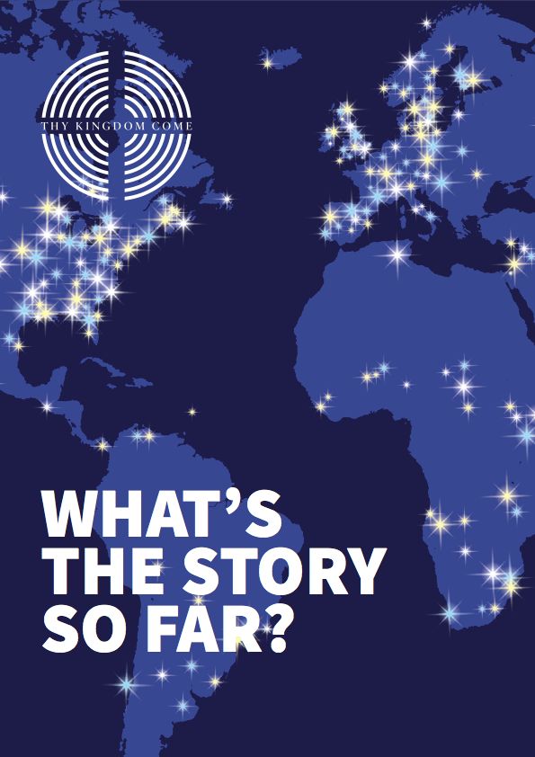

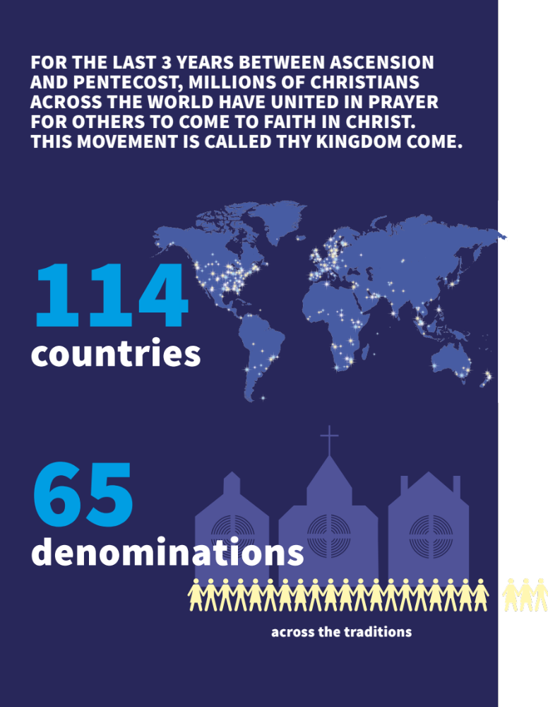

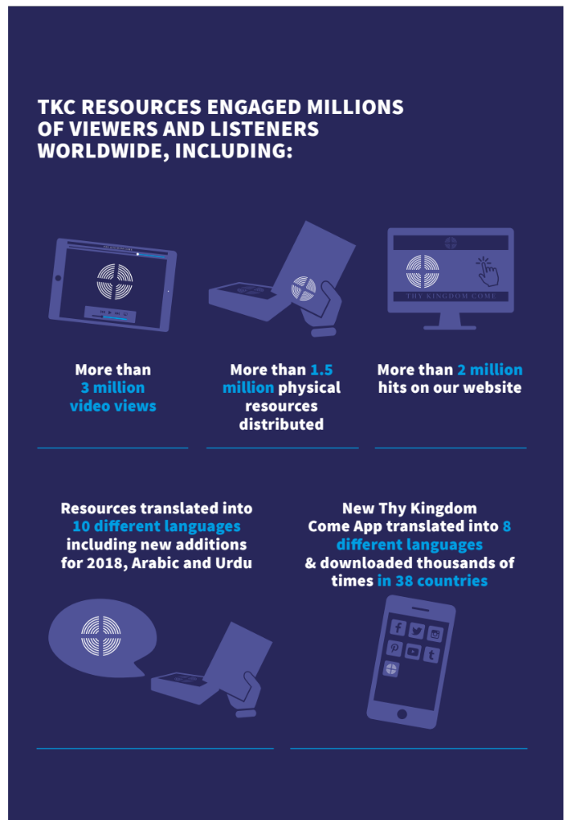

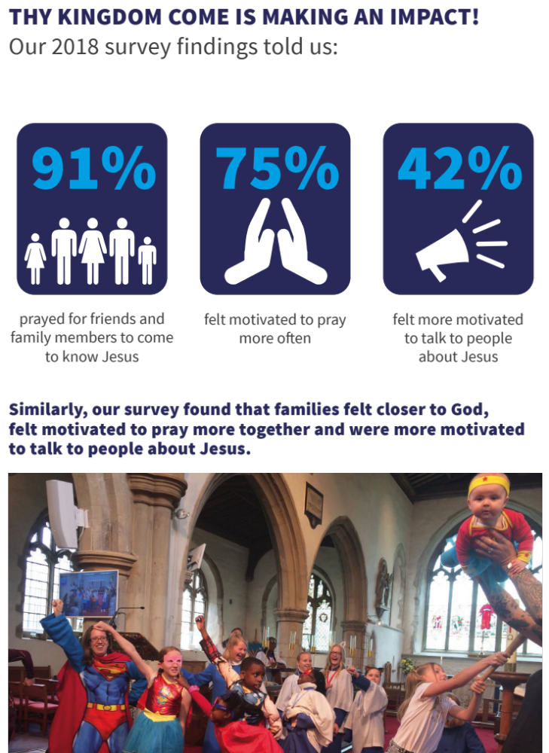

Churches, families and individuals across the world, from South Sudan to South Korea, Australia to Austria, participated in Thy Kingdom Come.

From prayer stations to continuous prayer, prayer walking to Messy Church services for families, beacon events to prayer buses, literally thousands of events took place over the 11 days. Beacon events brought together thousands of people in one place, from across the denominations and traditions, to celebrate, pray and worship together.

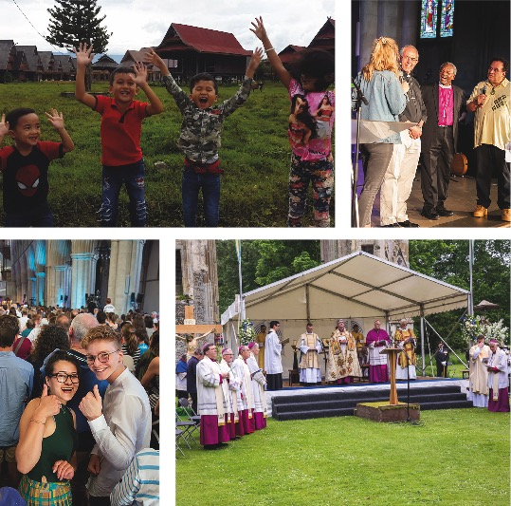
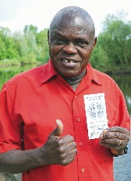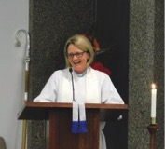
“Earlier this year, we were recently encouraged and challenged to be light in our community and ‘do something’. When I looked at the TKC website I saw the places that joined up, were lights lit up around the world and lo and behold the words ‘Do something’ jumped off the page. It has become that way that we could not but help see God’s call to us to join with our brothers and sisters around the globe and pray Thy Kingdom Come.”
Revd Tracey Wolsley, Rector, Anglican Parish of Kangaroo Flat, Australia
“Our children have started praying more confidently and freely after spending so much time in our prayer room.”
“I went to speak at a youth event in the north of England and mentioned Thy Kingdom Come in my talk. A young man, no more than 16 years old, shot up his hand and said, ‘Yeah I know about that.’ Then he pointed to his friend sitting next to him and said,
‘I prayed for him last year. He was one of the 5 I prayed for and now he’s here!’”

“As a cathedral it has enabled us to renew and strengthen links with deaneries and parishes across our diocese and we hope and pray that these links will grow stronger, so that we can be a better resource for mission in our diocese.”
Rochester Cathedral
“Thy Kingdom Come invited us to pray for five people. I asked God who I should pray for… and sure enough, lots of people came to mind but five particular people stood out in my prayers. I have been praying for these five people for the last year. This Thy Kingdom Come my prayer for them was fervent: ‘God you know them and love them. Holy Spirit fill them.’ I asked God to help me to be a witness to His life in all its fullness in Jesus Christ. Two of them have come to faith in God through Jesus Christ! They came to the beacon celebration and I rejoiced with them. Life is transformed and so rich and deep! I’m praying for the other three and have added two more so I’m still praying for five people. Who should you pray for? Start praying!”
Archbishop of York, Dr John Sentamu
We never cease to be amazed by the countless stories of the transformation and difference Thy Kingdom Come has made. Whether testimonies of people coming to faith; congregations renewing their commitment to increase corporate prayer; individuals feeling more empowered to share their faith, or families feeling more inspired to pray and study the Bible together. Here is a selection of some of the testimonies which have come through from this year’s Thy Kingdom Come:
Thy Kingdom Come legacy – 11 days and beyond:

Beyond the 11 days, Thy Kingdom Come has become a catalyst for many churches to work in new and different ways. This includes greater ecumenical collaboration, an increased commitment to evangelism and witness, to simply bringing an individual church community closer together.

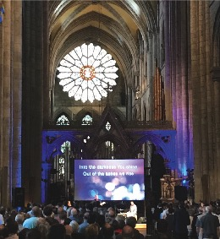
Case study 1:
Thy Kingdom Come across the denominations in Durham
In Durham, 14 churches including, from across the denominations, came together for 250 hours of non-stop, 24-7 prayer during Thy Kingdom Come.
The event was hosted by Salvation Army’s Sanctuary 21 – a house of prayer and hospitality – right in the heart of the city.
On the morning of the 10th, Church leaders from across the city gathered to launch the 11 Days of Prayer.
Hundreds of people came to pray in the space over the period with at least one person committing their lives to Christ for the first time and many others going deeper in their discipleship.
The initiative brought together people of all ages and students from Durham university came to pray day and night. Cranmer Hall theological college students joined in and Burn 24-7 worship events were held on the two weekends drawing large crowds as music flowed out into the street. The week culminated in a huge beacon event at Durham Cathedral with people uniting in prayer from across the whole of the North East region.
Since Thy Kingdom Come ended, a group of the students have followed up with a 24-5 prayer space in June and are planning a weekly 24 /1 prayer event in the space as soon as the new term begins. Monthly Burn events will also happen there in the future.
Case study 2:
Thy Kingdom Come in rural France
“I go to a rural church in South West France and we held a daily time of prayer throughout the 10 days – which was so uplifting. We used the service structure from your website to help us and began each time of prayer began with the ‘Your Kingdom Come’ song which we learned to sing! We have approximately 40 church members but during the holiday period, we tend to have many visitors, and were amazed to see how many stayed to listen to us sing - some even joined in the singing and for prayer too! We received so many insights and blessings from this special time of prayer and it brought us closer together as a church community. We’re planning to do this again next year - thank you and thank God!”

Other highlights:

Music video and song:
A new song, written by Pete James, has been downloaded thousands of times and has received national and international airplay. The stunning music video was filmed at the iconic St Paul’s Cathedral and has amassed tens of thousands of views on social media and has been broadcast on national TV. The song was sung at numerous festivals including Spring Harvest and featured on their new Live worship album. An African Gospel version of the song was produced by award-winning artist, Muyiwa. Both versions of the song helped TKC to connect with completely new audiences.
Thy Kingdom Come beacon events have brought tens of thousands of people together in person. Some have also been live streamed reaching a global audience. In 2017, the Archbishop of Canterbury preached at a Pentecost beacon event which was broadcast live on BBC 1. Similarly, Thy Kingdom Come beacon events have also featured on special radio broadcasts including BBC Radio 4’s Sunday Worship programme and on Premier Christian Radio.
Collectively, these broadcasts, along with live streaming on Facebook and YouTube, have resulted in millions of views / engagements. This year, Thy Kingdom Come Facebook Live content including the Archbishop of Canterbury live and in conversation with American writer and activist, Shane Claiborne, had a social media reach of almost ¼ million. This year, the finale of Thy Kingdom Come coincided with the Royal Wedding at which Archbishop Justin Welby officiated. Presiding Bishop of The Episcopal Church in America, Michael Curry, shared the Good News of Jesus in an electrifying sermon to a global audience of two billion. After that, they both travelled to St Albans Cathedral beacon event later that day!

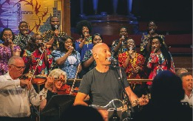
International and national media coverage:
Thy Kingdom Come 2018 received national, international, trade and specialist media coverage - print, broadcast and online - including BBC News, The Sunday Times, Premier Christian Radio, Church Times, TBN, The Tablet and UCB radio.

